**Create a file named student with fields (roll no, student name, marks). Fields are separated by colon “:” .**

**INPUT**

**Display the content of file.**

cat student.dat

**OUTPUT**

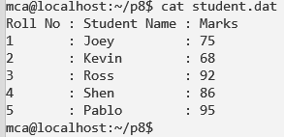

**INPUT**

**Search for name of your friend.**

grep -i shen student.dat

cut -d ":" -f 2 student.dat | grep -i kevin

**OUTPUT**

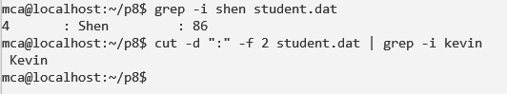

**INPUT**

**Delete the given file.**

rm student.dat

**OUTPUT**

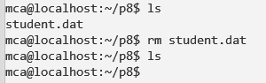

**INPUT**

**Create the link for the given file.**

ln -s student.dat /home/mca/

go to home directory and execute below command.

ll

**OUTPUT**

